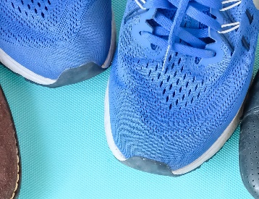

GYM SHOE GIVEAWAY
Donated by Samaritan’s Feet

WHEN: October 27th and 29th, 2020
SIZES: Girls’ and boys’ shoe sizes 1- 5

HOW TO ORDER:
- Complete the order form below with students’ names and shoe sizes.
- Return the form to the main office by October 23rd.
- Calls will be made if your order cannot be filled.
HOW TO PICK-UP
- TRADITIONAL STUDENTS and HYBRID STUDENTS: Students will be given shoes to take home in their bookbags on Tuesday, October 27th.

- ONLINE STUDENTS: Parents will pick up their child’s shoes on the same day they pick up food for the week on Thursday, October 29th- 12:00 to 1:30 P.M.
---------------------------------Tear Here – Return by Oct. 23rd ------------------------------Parent/Guardian’s Name: ______________________ Phone: ________
Student’s Name | Shoe size
Return to Riverside office by Friday, October 23rd

